Design patterns-Bernardo Carvalho 60012

Class location: \ganttproject\src\main\java\net\sourceforge\ganttproject\resource\HumanResource.java

This design pattern is a singleton because the variable myloadDistribution is only initiated on the get method which returns it.

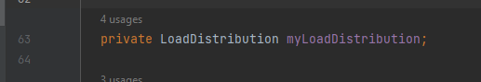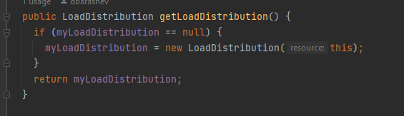

Class location: \ganttproject\src\main\java\net\sourceforge\ganttproject\undo\UndoableEditImpl.java

The following design pattern is known as Memento Pattern. It is used in order to return an object to one of its previous states.

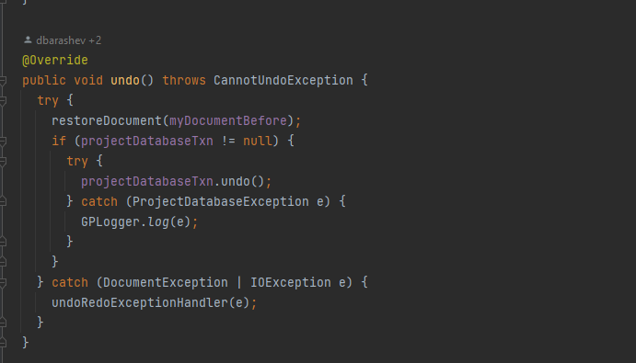

Class location:

\ganttproject/blob/master/biz.ganttproject.desktop/src/biz/ganttproject/desktop/DesktopAdapter.java

This code pattern is the Adapter Pattern which is used to facilitate the communication between two systems of the program.

